**Experiment 13**

**Aim:** Implement Docker Container Restart Policy.

**Procedure:**

There are **four** types of Restart Policies in **docker**, they are:

* **no**: The following is by default
* **always**: In the following if the container stops it is restarted as soon as the docker daemon reloads.
* **unless-stopped:** In the following the container will not restart if it is stopped manually or otherwise even after the docker daemon reloads.
* **on-failure:** In the following the container will restart if it exits because of an error.

We give the restart policy to the container while creating it using the **–restart** option.

For **always** option:

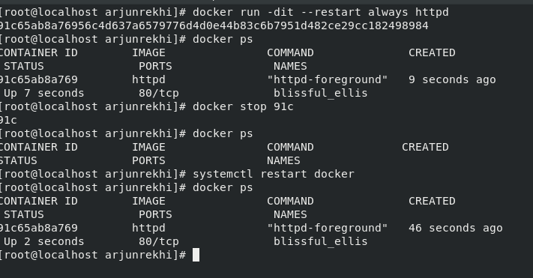

As it can be seen the **container restarts** as soon as the **daemon reloads**.

For **unless-stopped** option**:**

Updating the restart policy using the **docker update --restart unless-stopped** command.

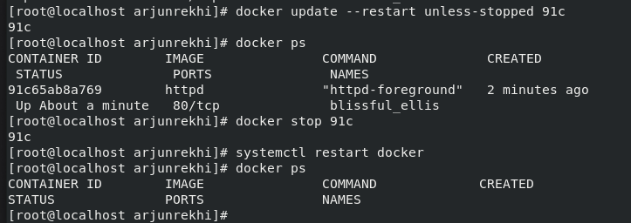

As it can be seen the container **does not restart** after the **daemon reloads**.

For **no** option:

Updating the restart policy using the **docker update --restart unless-stopped** command.

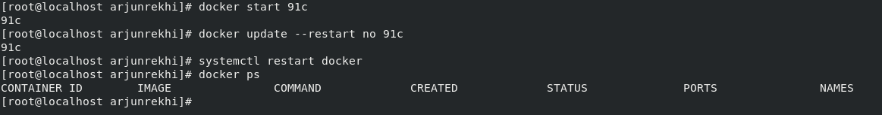

As it can be seen the container **does not restart** after the **daemon reloads**.

**Submitted by:**

Arjun Rekhi

500068109

R171218028